**Ansible :**

* Ansible is an IT automation tool that automates configuration management, cloud provisioning, deployment and orchestration.
* 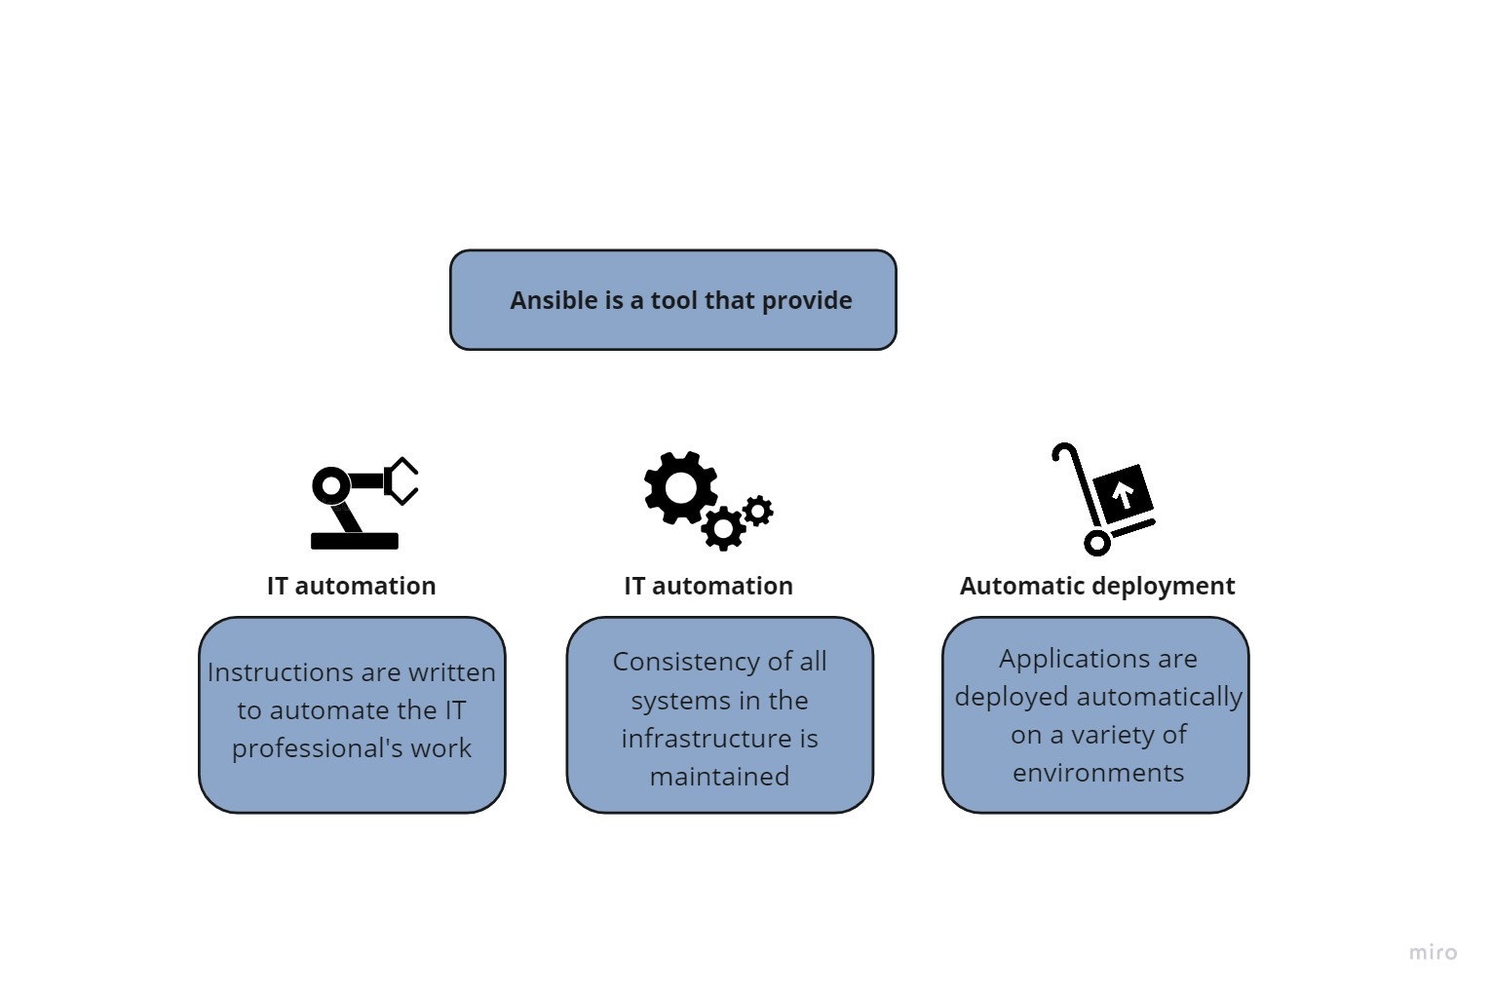The core of Ansible playbooks are written in YAML. (Should really do a section on YAML as we have seen this a few times)

**Difference between configuration management tool :**

This table describe the main differences between the automation management tools:

|  |  |  |  |  |
| --- | --- | --- | --- | --- |
| Tool | Ansible | chef | puppet | terraform |
|  | Configuration management tool | Configuration management tool | Configuration management and deployment tool | Orchestration tool |
| Architecture | Client only | Client/server | Client/server | Client only |
| Language | Python & yaml | Ruby, ERB & Json | Ruby, puppet DSL, ERB | HCL |
| Installation process | Easy | Time intensive and complex due to chef workstation | Time intensive due to master-agent certificate signing | Easy |
| Configuration management | Push & pull | Pull | Pull |  |

**Install and configure ansible on Debian 11 :**

By default, the Ansible package is not included in the Debian default repository.

There are two ways to install Ansible on Debian 11.

* Using apt command
* Using pip command

And in this installation, we will choose the first option, first we update the repository

$ Sudo apt install

$ Sudo apt install vim

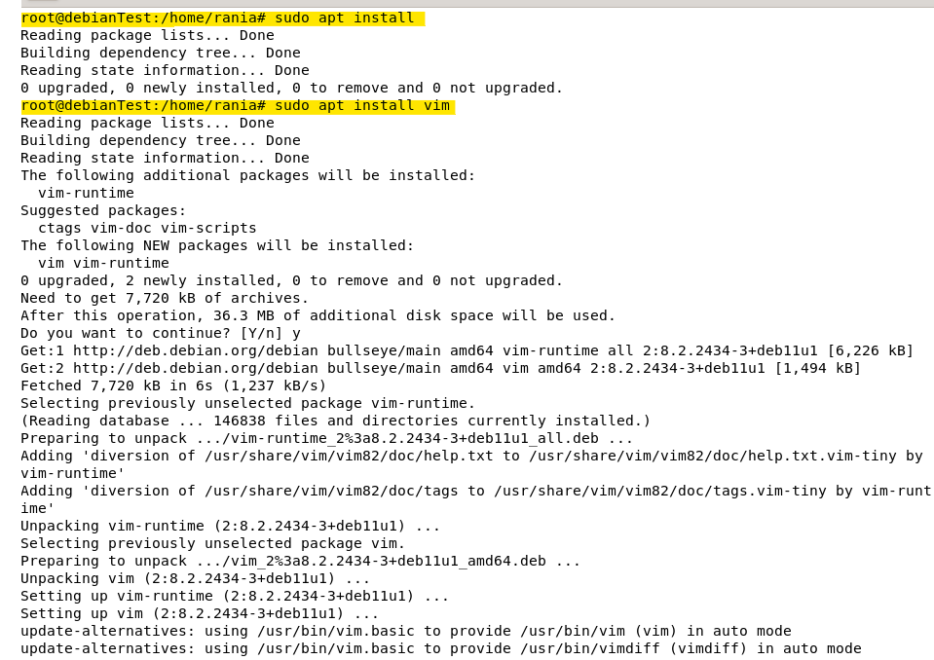

Then using apt command, install ansible in debian 11

$ sudo apt install ansible

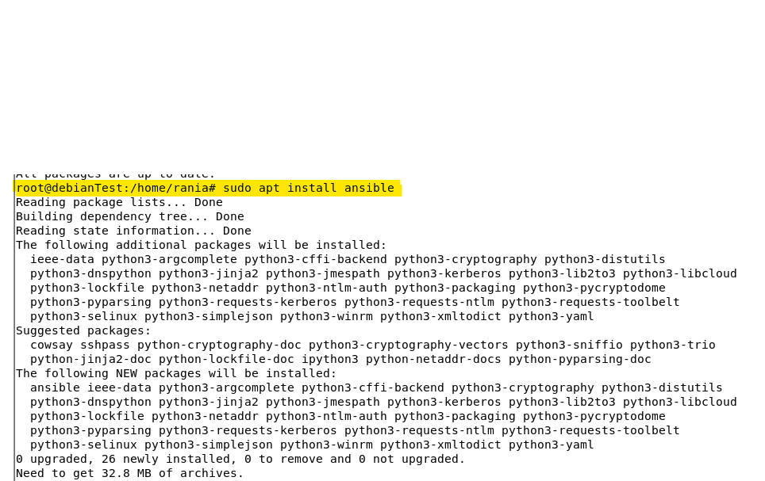

Once the Ansible is installed, we can determine the directory and verify the Ansible version with the following command :

$ ansible --version

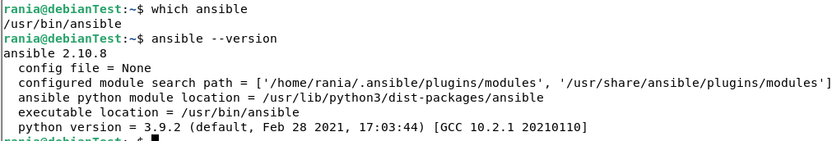

**Install and configure ansible on CentOS 7 :**

## Step 1 — Installing Ansible

First, we have to check that the centos epel repository is installed using this command :

$ sudo yum install epel-release

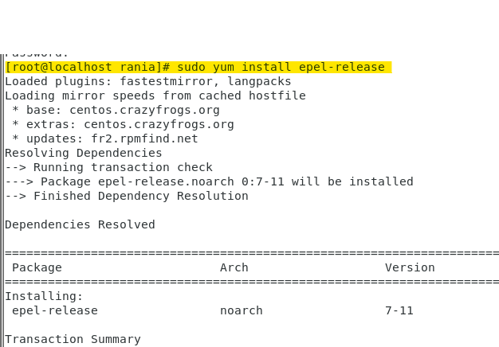

Once the repository is installed, we can install ansible with yum:

$ sudo yum install ansible

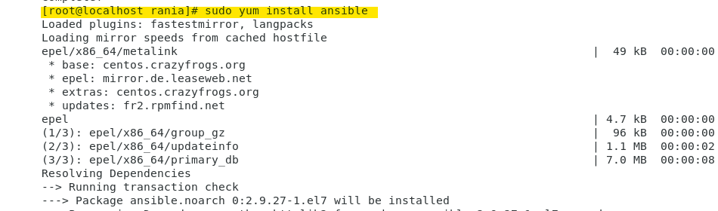

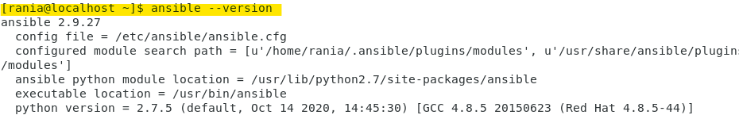

## Step 2 — Configuring Ansible Hosts

To test Ansible, we need to generate an ssh key on my local machine, once completed we have to copy the public key in client server by using these commands

$ ssh-keygen

$ ssh-copy-id root@192.168.129.129

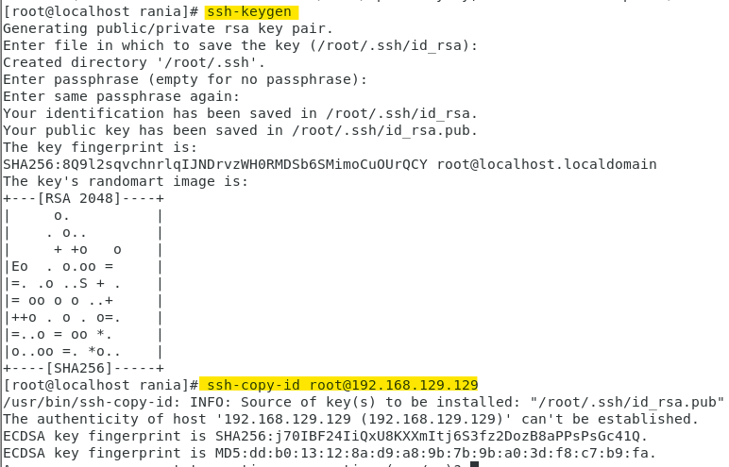

Next we need to configure ansible hosts by adding the client server ip

vi /etc/ansible/hosts

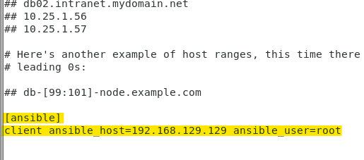

To test the configuration, execute this command below and as you can see our configuration is completely successful.

$ ansible -m ping all

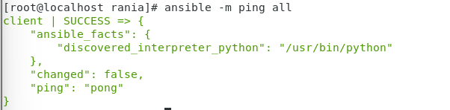

[1] <https://docs.ansible.com/ansible/latest/installation_guide/installation_distros.html#installing-ansible-on-fedora-or-centos>

[2] https://www.youtube.com/watch?v=cEnq94dYrSg&ab_channel=LinuxHelp